**Exploratory Data Analysis (EDA) on Indian Food**

## **Naan Mudhalvan project report**

**Submitted by,**

**TEAM**

**NM2023TMID08426**

**Team Lead -** PERUVAILU KAMAL

**Team member 1 -** MANKU SRINADH

**Team member 2 -** MARRIPUDI CHARAN

**Team member 3 -** MADALA CHAITANYA



**ARJUN COLLEGE OF TECHNOLOGY**

**COIMBATORE- 642 120**

## **ANNA UNIVERSITY: CHENNAI 600 025**

## **NOV 2023**

Project Report Format

# INTRODUCTION

* 1. Project Overview
  2. Purpose

# LITERATURE SURVEY

* 1. Existing problem
  2. References
  3. Problem Statement Definition

# IDEATION & PROPOSED SOLUTION

* 1. Empathy Map Canvas
  2. Ideation & Brainstorming

# REQUIREMENT ANALYSIS

* 1. Functional requirement
  2. Non-Functional requirements

# PROJECT DESIGN

* 1. Data Flow Diagrams & User Stories
  2. Solution Architecture

# PROJECT PLANNING & SCHEDULING

* 1. Technical Architecture
  2. Sprint Planning & Estimation
  3. Sprint Delivery Schedule

# CODING & SOLUTIONING (Explain the features added in the project along with code)

* 1. Feature 1
  2. Feature 2
  3. Database Schema (if Applicable)

# PERFORMANCE TESTING

* 1. Performace Metrics

# RESULTS

* 1. Output Screenshots

# ADVANTAGES & DISADVANTAGES

1. **CONCLUSION**

# FUTURE SCOPE

1. **APPENDIX**

Source Code

GitHub & Project Demo Link

# 1.INTRODUCTION

* 1. **Project** **Overview**:

The Food EDA project aims to analyze and gain insights from a dataset related to the food industry. By conducting a thorough EDA, we seek to uncover trends, patterns, and valuable information that can help in making informed decisions and recommendations for stakeholders in the food industry.

* 1. **Purpose:**

1. Promoting Healthy Eating
2. Preventing Diet-Related Health Issues
3. Culinary Skills
4. Sustainability
5. Cultural and Food Literacy
6. Empowering Consumers
7. Fostering a Positive Relationship with Food
8. Educating Children

**2.LITERATURE SURVEY:**

**2.1 Existing problem**

A literacy survey of existing problems in food education can help identify areas where improvements are needed. Here are some common problems and challenges associated with food education:

1. Lack of Access to Nutritious Food: In many communities, there is limited access to affordable, nutritious food, which can hinder people's ability to make healthy food choices, regardless of their food education. This issue often disproportionately affects low-income individuals and those in food deserts.

2. Nutrition Gaps: Traditional food education often focuses on basic nutrition, but it may not address specific dietary needs for individuals with allergies, intolerances, or dietary restrictions, such as gluten-free or vegan diets.

3. Inadequate School-Based Food Education: While some schools offer food education, it's not always comprehensive, and the quality can vary widely. Additionally, not all schools include practical cooking skills as part of their curriculum.

4. Food Advertising and Marketing: The pervasive marketing of unhealthy and highly processed foods can undermine the efforts of food education programs. These marketing practices can make it challenging for individuals to make healthy choices.

5. Food Literacy Gaps: Many people lack basic food literacy skills, such as reading and understanding food labels, meal planning, and cooking. These skills are essential for making informed food choices.

6. Cultural and Socioeconomic Barriers:Cultural and socioeconomic factors can significantly impact food choices. Food education programs must consider cultural diversity and the economic constraints that influence people's eating habits.

7. Food Waste: Food education often overlooks the issue of food waste, which is a significant problem in many countries. Teaching individuals about reducing food waste is crucial for both environmental and economic reasons.

8. Consumer Confusion:The abundance of conflicting information about nutrition and diet can leave consumers confused and unsure about what to eat. Food education should help people navigate this information and make informed choices.

9. Limited Culinary Skills: While food education may emphasize the importance of cooking and meal preparation, not everyone has the necessary culinary skills. This can discourage people from preparing their meals at home.

10. Sustainability Education: Food education should include more emphasis on sustainable and eco-friendly food choices. Many people are unaware of the environmental impact of their food choices.

11. Health Disparities:Health disparities related to diet and nutrition exist across different demographics. Food education must address these disparities and work to ensure equitable access to nutritional information and resources.

12. Time Constraints: Busy lifestyles and work-related time constraints can make it difficult for individuals to prioritize healthy eating and cooking. Food education should provide practical solutions for people with limited time.

13. Lack of Parental Education: Parents play a crucial role in shaping children's food choices, so educating parents about healthy eating practices is essential.

A literacy survey can help tailor food education programs to address these and other specific challenges in a given community or population. It's important to consider local needs and cultural factors to create effective food education initiatives.

* 1. **References:**

It appears that you're looking for references related to a "literacy survey" in the context of food education (food eda). However, the term "literacy survey" doesn't typically relate to food education. It's possible you meant to ask about references or sources for a research survey or study related to food education. If that's the case, here are some references and sources that you can consider for your research on food education:

**1. Academic Journals:** Worsley, A., Wang, W. C., & Hunter, W. (2018). A food literacy survey and food safety knowledge indicators. Food Control, 90, 342-349.

2. Vidgen, H. A., & Gallegos, D. (2014). Defining food literacy and its components. Appetite, 76, 50-59.

3.Lavelle, F., McGowan, L., Spence, M., & Caraher, M. (2016). Barriers and facilitators to cooking from 'scratch' using basic or raw ingredients: A qualitative interview study. British Food Journal, 118(10), 2477-2490.

**2. Books and Publications:**

- Horton, D. (2018). Food Literacy: Key Concepts for Health and Education. Routledge.

- Vidgen, H. A., & Gallegos, D. (2015). Food literacy: Key concepts for health and education. In Food Literacy (pp. 1-7). Springer.

**3. Government Reports and Guidelines**: The Center for Disease Control and Prevention (CDC) offers resources and reports related to food and nutrition education, particularly in the context of public health.

**4. Websites and Organizations:** The Food Literacy Center (foodliteracycenter.org) is an organization that focuses on food education and provides valuable resources and information.

2.The Food and Agriculture Organization (FAO) of the United Nations offers reports and publications on food education and sustainability.

Please note that the specific references you choose will depend on the focus and scope of your research survey on food education. You may also want to consult academic databases and libraries to find additional sources and research papers related to your specific area of interest within food education.

* 1. **Problem Statement Definition**

A literacy survey, in the context of a problem statement definition for food exploratory data analysis (EDA), typically involves an assessment of the existing knowledge and research related to the topic. It is a critical step in the research process to understand the current state of knowledge and identify gaps or problems that the EDA aims to address. Here's how you can define a problem statement for food EDA with a literacy survey:

**Problem Statement Definition for Food EDA:**

**Background and Context:**

Food EDA involves the analysis of food-related data to gain insights into various aspects of the food industry, nutrition, consumption patterns, and related factors. Before conducting an EDA, it is essential to understand the existing knowledge and research in this field.

**Problem Statement:**

The problem we aim to address is the lack of comprehensive data-driven insights into the following areas within the domain of food:

**1. Nutritional Analysis**: While there exists a wealth of nutritional data, there is a need to conduct EDA to identify trends and patterns in nutritional content across various food products and categories. This will enable us to better understand the nutritional landscape and its impact on public health.

**2. Consumer Behavior**: Understanding consumer preferences, purchasing patterns, and the factors influencing food choices is vital. Current research may not provide a holistic view of evolving consumer behavior and its implications for the food industry.

3. **Supply Chain and Sustainability**: The food industry's supply chain, food waste, and sustainability practices require closer examination through EDA. This includes the assessment of environmental impact and the identification of areas for improvement.

4**. Food Safety and Quality**: Data analysis can contribute to enhancing food safety and quality control measures. It is imperative to identify the gaps in existing research and determine how EDA can be applied effectively.

**5. Food Marketing and Trends:** EDA can uncover insights into food marketing strategies, emerging food trends, and the impact of marketing on consumer choices. However, the current literature may not provide a comprehensive view of these aspects.

**Literacy Survey:**

To define the problem statement effectively, a comprehensive literacy survey will be conducted. This survey will involve a systematic review of existing literature, research papers, and datasets related to food EDA, covering the aforementioned areas. The survey will assess the current state of knowledge, identify gaps, limitations, and inconsistencies in the available research, and pinpoint areas where data-driven analysis can make significant contributions.

**Objectives:**

The primary objectives of this study are to:

- Identify existing gaps and limitations in food-related research.

- Determine the key challenges and opportunities in the field of food EDA.

- Highlight areas where exploratory data analysis can lead to valuable insights and inform decision-making in the food domain.

**Methodology:**

The methodology will involve a structured review of peer-reviewed articles, government reports, industry publications, and relevant datasets. Data sources will be systematically evaluated and analyzed to extract relevant information.

By conducting a comprehensive literacy survey and defining the problem statement, we aim to provide a strong foundation for the subsequent food EDA and contribute to a deeper understanding of critical issues in the food domain.

# IDEATION & PROPOSED SOLUTION

* 1. Empathy Map Canvas

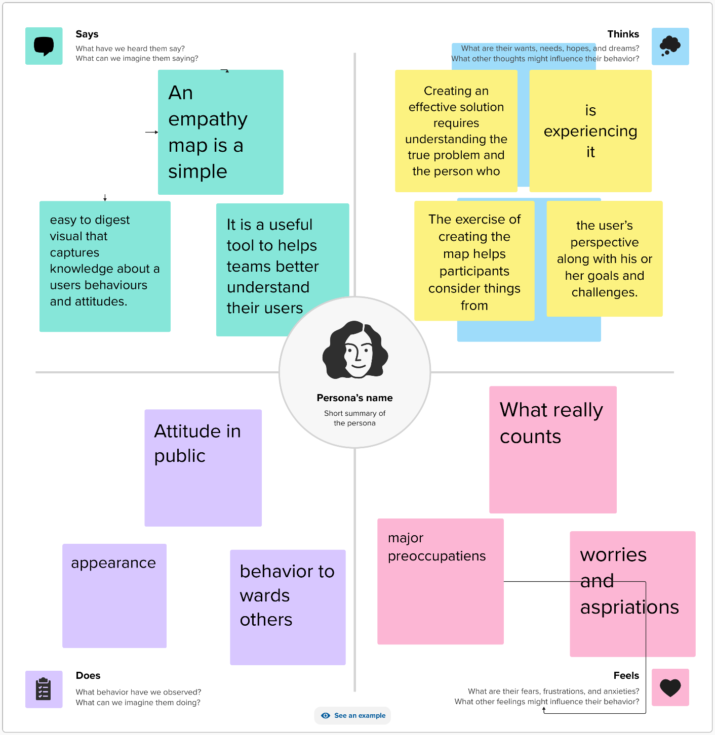

3.2 **Ideation & Brainstorming**

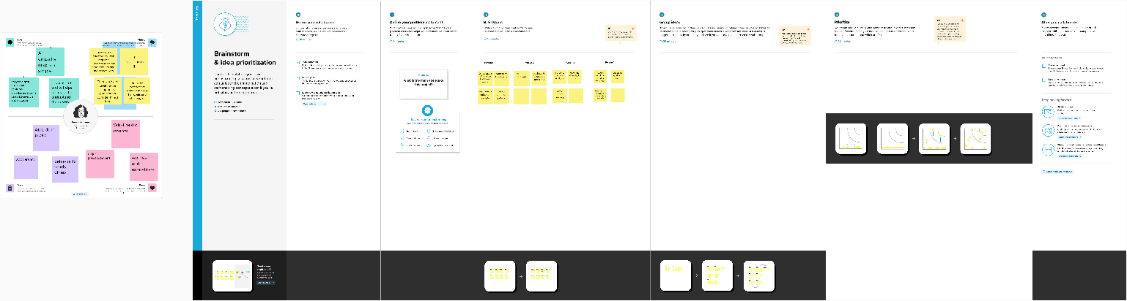

# 4.REQUIREMENT ANALYSIS

* 1. **Functional requirement**

Functional requirements for a Food Exploratory Data Analysis (EDA) project typically outline the specific functions and capabilities that the EDA system or software should have to meet its goals. Here are some functional requirements for a Food EDA project:

**1. Data Import and Integration:**

- The system should allow users to import diverse data sources, including nutritional databases, sales records, supply chain data, and consumer feedback.

- It should support data integration, cleansing, and transformation to prepare data for analysis.

**2. Data Exploration and Visualization:**

- The system should provide various statistical and visualization tools for users to explore and understand food-related data.

- Users should be able to create histograms, scatter plots, box plots, and other relevant visualizations.

- It should offer interactive dashboards for real-time data exploration.

**3. Nutritional Analysis:**

- The system should enable users to analyze the nutritional content of different food products.

- It should calculate and disp

lay macronutrients, micronutrients, calories, and other relevant nutritional information.

- Users should be able to compare the nutritional profiles of various food items.

**4. Consumer Behavior Analysis:**

- The system should allow users to analyze and visualize consumer behavior data, including purchasing patterns, preferences, and demographics.

- It should support cohort analysis and segmentation based on consumer characteristics.

**5. Supply Chain and Sustainability Analysis:**

- The system should provide tools to analyze the food supply chain, including sourcing, transportation, and distribution data.

- It should calculate and display environmental impact metrics, such as carbon footprint and water usage.

- Users should be able to identify opportunities for sustainability improvements.

**6. Food Safety and Quality Control:**

- The system should include features for monitoring food safety and quality data.

- It should offer alerts and notifications based on predefined quality thresholds.

- Users should be able to track quality control measures over time.

**7. Data Mining and Pattern Recognition:**

- The system should have data mining capabilities to discover hidden patterns and trends within the data.

- It should include machine learning algorithms for predictive modeling and anomaly detection.

**8.Food Marketing and Trends Analysis:**

- The system should support the analysis of marketing campaigns, social media mentions, and other relevant marketing data.

- It should identify trends, sentiment analysis, and correlations between marketing efforts and consumer behavior.

**9. Custom Reporting and Export:**

- Users should be able to generate customized reports and export data and visualizations in various formats (e.g., PDF, Excel, CSV).

- The system should support automatic report scheduling.

**10. User Management and Access Control:**

- The system should provide user authentication and role-based access control.

- Administrators should be able to manage user accounts and permissions.

**11. Scalability and Performance:**

- The system should be scalable to handle large volumes of data.

- It should be optimized for performance to ensure responsive data analysis.

**12. Data Security and Privacy:**

- The system should adhere to data privacy regulations and protect sensitive data.

- It should support data encryption and access controls.

**13. Data Versioning and Auditing:**

- The system should maintain version control of datasets and provide an audit trail for changes and actions taken by users.

**14. Documentation and Help Features:**

- The system should include comprehensive documentation and user guides.

- It should offer online help resources and tooltips within the interface.

**15. API Integration:**

- The system should provide APIs for integration with other software and systems.

These functional requirements will help ensure that the Food EDA system can effectively analyze and provide insights into various aspects of the food domain, from nutrition and consumer behavior to supply chain and sustainability. The specific requirements may vary based on the project's scope and goals.

**4.2 REQUIREMENT ANALYSIS**

Non-functional requirements for food exploratory data analysis (EDA) are essential to ensure that the data analysis process and the system or tools used to perform EDA meet specific criteria related to performance, usability, security, and other aspects. Here are some non-functional requirements for a food EDA system:

**1. Performance:**

**Speed:** The EDA system should provide fast and responsive data analysis, ensuring that users can interact with and explore data without significant delays.

**Scalability:** The system should be scalable to handle increasing amounts of food-related data as the dataset grows over time.

**Efficiency:** Data analysis processes should be optimized to make the most efficient use of computing resources.

2. **Usability:**

**User-Friendly Interface**:The EDA tool should have an intuitive and user-friendly interface that allows users to easily explore and visualize food data.

**Accessibility:** The system should be designed to accommodate users with disabilities, ensuring that it is accessible to a wide range of individuals.

**Documentation:** Comprehensive documentation should be provided to guide users on how to use the EDA system effectively.

**3. Security:**

**Data Privacy:** Food data often contains sensitive information, and the EDA system should have robust data privacy and access control mechanisms to protect this data from unauthorized access.

**Authentication and Authorization:** Users should be required to authenticate before accessing the system, and role-based access control should be implemented to restrict access to specific functionalities or data.

4**. Reliability**:

**Availability:** The EDA system should be highly available, with minimal downtime to ensure that users can access and analyze food data whenever needed.

**Error Handling**: The system should have effective error handling mechanisms to gracefully recover from failures and prevent data loss.

5. **Data Quality:**

**Data Integrity:** The EDA system should have measures in place to maintain the integrity of the food data, ensuring that it remains accurate and reliable throughout the analysis process.

**Data Cleaning and Preprocessing:** The system should include data cleaning and preprocessing capabilities to handle missing values, outliers, and inconsistencies in the food dataset.

6. **Scalability and Extensibility:**

**Compatibility**: The EDA system should be compatible with various data formats, sources, and data storage systems, allowing for integration with a wide range of data types and platforms.

**Modularity:** The system should be designed in a modular fashion, allowing for easy extensions and integrations with new data sources and analysis techniques.

7. **Performance Monitoring and Reporting:**

**Monitoring**: The system should provide monitoring and reporting tools to track the performance and resource usage, helping to identify and resolve any performance issues.

**Reporting:** The EDA tool should generate reports and insights based on the analyzed food data, making it easy for users to understand and share the results.

**8.Compliance:**

Regulatory Compliance: Ensure that the system complies with relevant regulations and industry standards, especially those related to food data, privacy, and security.

9. **Interoperability:**

**Integration**: The EDA system should support integration with other data analysis tools, software, and systems commonly used in the food industry.

10. **Cost-Effectiveness:**

**Resource Optimization**: Ensure that the system is optimized to use computing and storage resources efficiently, keeping operational costs in check.

Non-functional requirements are crucial for ensuring that the food EDA system not only performs data analysis effectively but also does so in a reliable, secure, and user-friendly manner while meeting regulatory and performance expectations.

# 5.PROJECT DESIGN

* 1. Data Flow Diagrams & User Stories

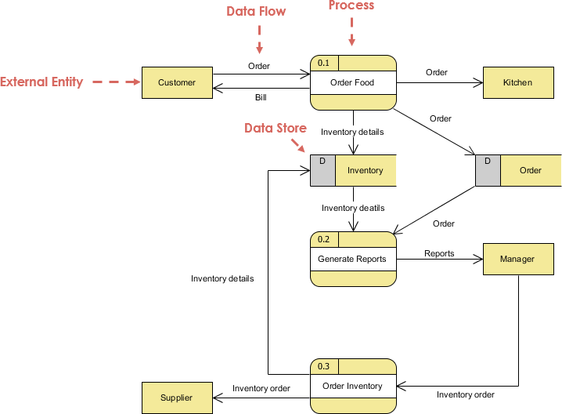

# 

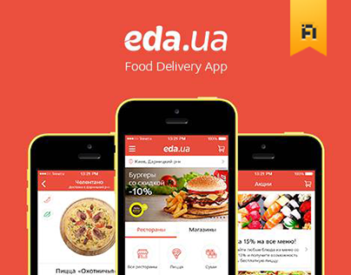

* 1. Solution Architecture

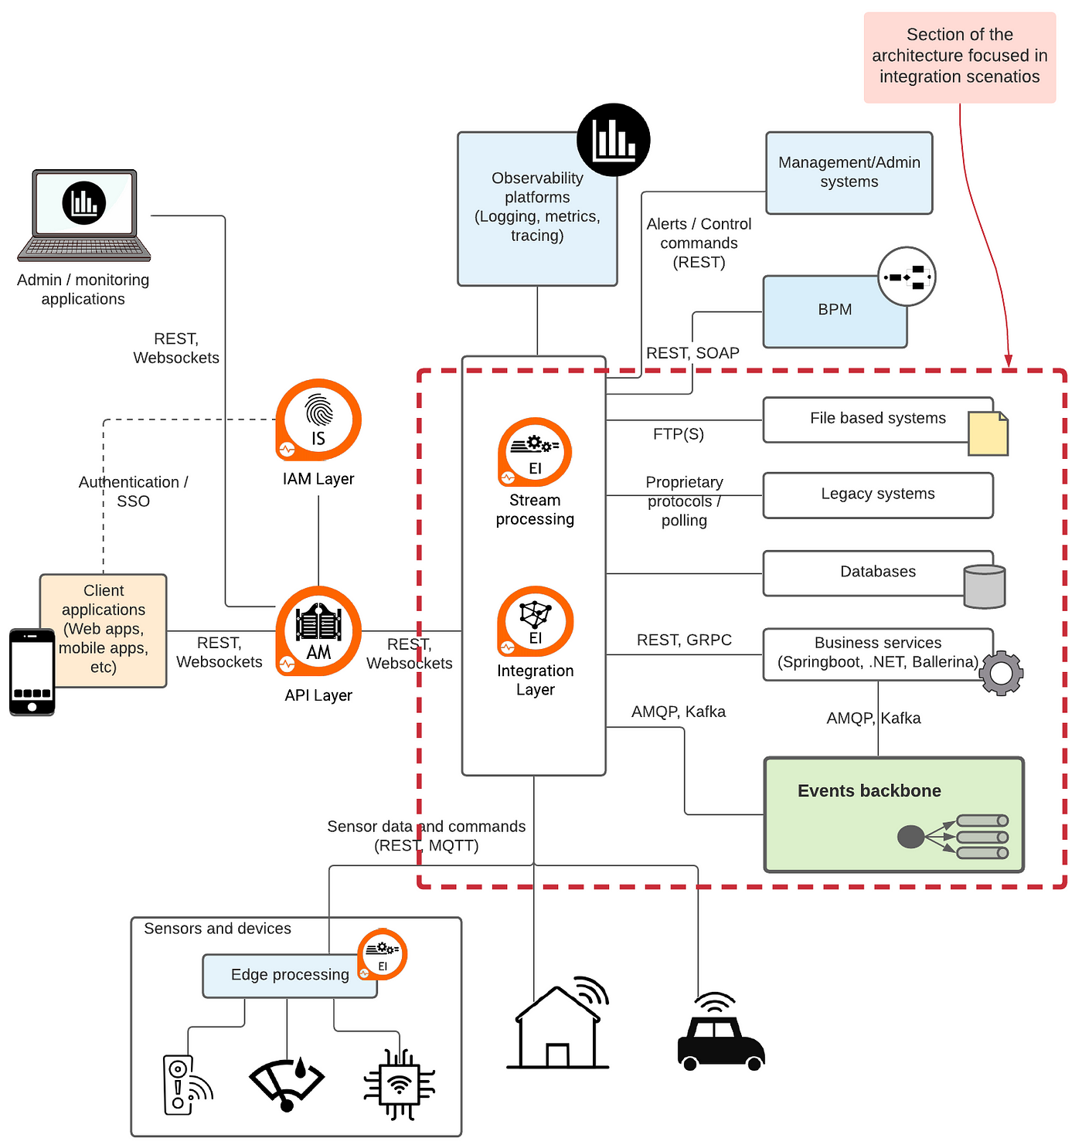

# 6.PROJECT PLANNING & SCHEDULING

* 1. Technical Architecture

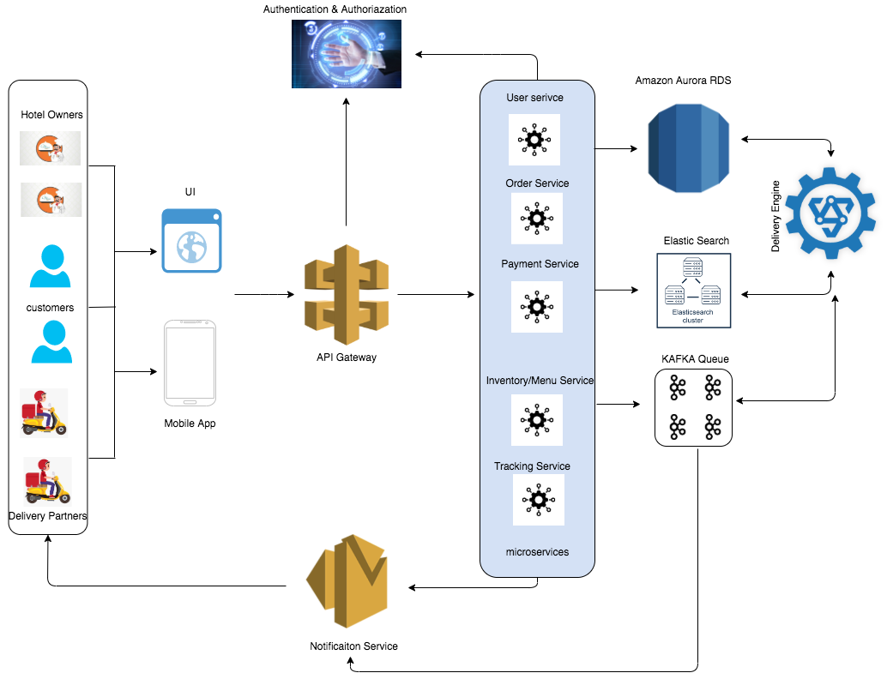

* 1. Sprint Planning & Estimation

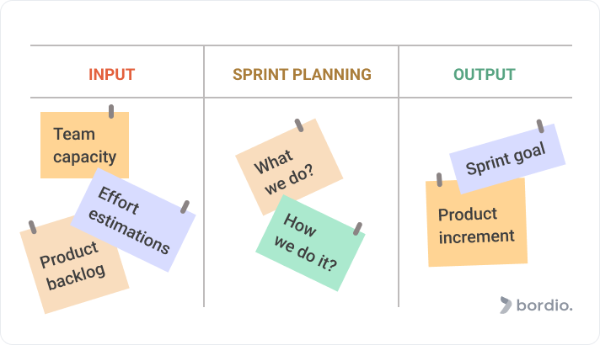

* 1. Sprint Delivery Schedule

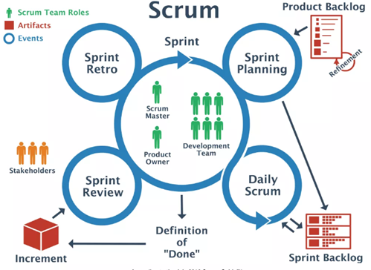

# 7.CODING & SOLUTIONING (Explain the features added in the project along with code)

# 7.1 Feature

<!DOCTYPE html>

<html lang="en">

<head>

  <meta charset="utf-8">

  <meta content="width=device-width, initial-scale=1.0" name="viewport">

  <title>Indian food EDA</title>

  <meta content="" name="description">

  <meta content="" name="keywords">

  <!-- Favicons -->

  <link href="assets/img/favicon.png" rel="icon">

  <link href="assets/img/apple-touch-icon.png" rel="apple-touch-icon">

  <!-- Google Fonts -->

  <link href="https://fonts.googleapis.com/css?family=Open+Sans:300,300i,400,400i,600,600i,700,700i|Krub:300,300i,400,400i,500,500i,600,600i,700,700i|Poppins:300,300i,400,400i,500,500i,600,600i,700,700i" rel="stylesheet">

  <!-- Vendor CSS Files -->

  <link href="assets/vendor/aos/aos.css" rel="stylesheet">

  <link href="assets/vendor/bootstrap/css/bootstrap.min.css" rel="stylesheet">

  <link href="assets/vendor/bootstrap-icons/bootstrap-icons.css" rel="stylesheet">

  <link href="assets/vendor/boxicons/css/boxicons.min.css" rel="stylesheet">

  <link href="assets/vendor/glightbox/css/glightbox.min.css" rel="stylesheet">

  <link href="assets/vendor/swiper/swiper-bundle.min.css" rel="stylesheet">

  <!-- Template Main CSS File -->

  <link href="assets/css/style.css" rel="stylesheet">

  <!-- =======================================================

  * Template Name: Bikin

  * Updated: Sep 18 2023 with Bootstrap v5.3.2

  * Template URL: https://bootstrapmade.com/bikin-free-simple-landing-page-template/

  * Author: BootstrapMade.com

  * License: https://bootstrapmade.com/license/

  ======================================================== -->

</head>

<body>

  <!-- ======= Header ======= -->

  <header id="header" class="fixed-top">

    <div class="container d-flex align-items-center justify-content-between">

      <h1 class="logo"><a href="index.html"></a>Indian food EDA</h1>

      <!-- Uncomment below if you prefer to use an image logo -->

      <!-- <a href="index.html" class="logo"><img src="assets/img/logo.png" alt="" class="img-fluid"></a>-->

      <nav id="navbar" class="navbar">

        <ul>

          <li><a class="nav-link scrollto active" href="#hero">Home</a></li>

          <li><a class="nav-link scrollto" href="#about">About</a></li>

          <li><a class="nav-link scrollto" href="#dashbord">Dashbord</a></li>

          <li><a class="nav-link scrollto" href="#story">Story</a></li>

          <li><a class="nav-link scrollto " href="#report">Report</a></li>

          <li><a class="nav-link scrollto" href="#contact">Contact</a></li>

        <i class="bi bi-list mobile-nav-toggle"></i>

      </nav><!-- .navbar -->

    </div>

  </header><!-- End Header -->

  <!-- ======= Hero Section ======= -->

  <section id="hero" class="d-flex align-items-center">

    <div class="container d-flex flex-column align-items-center justify-content-center" data-aos="fade-up">

      <h1>INDIAN FOOD EDA</h1>

      <h2>Unveiling the Flavors,Regional Delights, and Popularity Of Indian Cuisine</h2>

      <img src="C:\Users\91934\Downloads\download.jpg" class="img-fluid hero-img" alt="" data-aos="zoom-in" data-aos-delay="400">

      <a href="#about" class="btn-get-started scrollto">Get Started</a>

    </div>

  </section><!-- End Hero -->

  <main id="main">

    <!-- ======= About Section ======= -->

    <!-- End About Section -->

    <!-- ======= Clients Section ======= -->

    <!-- End Clients Section -->

    <section id="about" class="features" data-aos="fade-up">

      <div class="container">

        <div class="section-title">

          <h2>About</h2>

        </div>

        <p>Indian cuisine consists of a variety of regional and traditional cuisines native to the Indian subcontinent. Given the diversity in soil, climate, culture, ethnic groups, and occupations, these cuisines vary substantially and use locally available spices, herbs, vegetables, and fruits. Indian food is also heavily influenced by religion, in particular Hinduism, cultural choices and traditions.</p>

        </div>

    </section>

    <!-- ======= Features Section ======= -->

    <section id="dashbord" class="features" data-aos="fade-up">

      <div class="container">

        <div class="section-title">

          <h2>Dashbord</h2>

        </div>

        <iframe src="https://us3.ca.analytics.ibm.com/bi/?perspective=dashboard&amp;pathRef=.my_folders%2FIndia%2Beda%2Bdashboard&amp;closeWindowOnLastView=true&amp;ui_appbar=false&amp;ui_navbar=false&amp;shareMode=embedded&amp;action=view&amp;mode=dashboard&amp;subView=model0000018b8623a701_00000000" width="1350" height="900" frameborder="0" gesture="media" allow="encrypted-media" allowfullscreen=""></iframe>

      </div>

    </section><!-- End Features Section -->

    <!-- ======= Steps Section ======= -->

    <!-- End Steps Section -->

    <!-- ======= Services Section ======= -->

    <section id="story" class="services">

      <div class="container" data-aos="fade-up">

        <div class="section-title">

          <h2>Story</h2>

          </div>

          <iframe src="https://us3.ca.analytics.ibm.com/bi/?perspective=story&amp;pathRef=.my_folders%2FStory%253A%2BIndia%2Beda%2Bstory&amp;closeWindowOnLastView=true&amp;ui_appbar=false&amp;ui_navbar=false&amp;shareMode=embedded&amp;action=view&amp;sceneId=-1&amp;sceneTime=0" width="1350" height="900" frameborder="0" gesture="media" allow="encrypted-media" allowfullscreen=""></iframe>

      </div>

    </section><!-- End Services Section -->

    <!-- ======= Portfolio Section ======= -->

    <section id="report" class="portfolio">

      <div class="container" data-aos="fade-up">

        <div class="section-title">

          <h2>Report</h2>

          </div>

          <iframe src="https://us3.ca.analytics.ibm.com/bi/?perspective=story&amp;pathRef=.my_folders%2FStory%253A%2BIndia%2Beda%2Bstory&amp;closeWindowOnLastView=true&amp;ui_appbar=false&amp;ui_navbar=false&amp;shareMode=embedded&amp;action=view&amp;sceneId=-1&amp;sceneTime=0" width="1350" height="900" frameborder="0" gesture="media" allow="encrypted-media" allowfullscreen=""></iframe>

      </div>

    </section><!-- End Portfolio Section -->

    <!-- ======= Testimonials Section ======= -->

    <!-- End Testimonials Section -->

    <!-- ======= Team Section ======= -->

    <!-- End Team Section -->

    <!-- ======= Pricing Section ======= -->

    <!-- ======= Contact Section ======= -->

    <section id="contact" class="contact section-bg">

      <div class="container" data-aos="fade-up">

        <div class="section-title">

          <h2>Contact</h2>

           </div>

        <div class="row">

          <div class="col-lg-6">

            <div class="row">

              <div class="col-md-12">

                <div class="info-box">

                  <i class="bx bx-map"></i>

                  <h3>Our Address</h3>

                  <p>Arjun college of technology,coimbatore</p>

                </div>

              </div>

              <div class="col-md-6">

                <div class="info-box mt-4">

                  <i class="bx bx-envelope"></i>

                  <h3>Email Us</h3>

                  <p>peruvailukamal@gmail.com<br>srinadhmanku9347@gmail.com<br>charan@gmail.com<br>chaithanya@gmail.com</p>

                </div>

              </div>

              <div class="col-md-6">

                <div class="info-box mt-4">

                  <i class="bx bx-phone-call"></i>

                  <h3>Call Us</h3>

                  <p>+91 7569933770<br>+91 6309795062</p>

                </div>

              </div>

            </div>

          </div>

          <div class="col-lg-6 mt-4 mt-md-0">

            <form action="forms/contact.php" method="post" role="form" class="php-email-form">

              <div class="row">

                <div class="col-md-6 form-group">

                  <input type="text" name="name" class="form-control" id="name" placeholder="Your Name" required>

                </div>

                <div class="col-md-6 form-group mt-3 mt-md-0">

                  <input type="email" class="form-control" name="email" id="email" placeholder="Your Email" required>

                </div>

              </div>

              <div class="form-group mt-3">

                <input type="text" class="form-control" name="subject" id="subject" placeholder="Subject" required>

              </div>

              <div class="form-group mt-3">

                <textarea class="form-control" name="message" rows="5" placeholder="Message" required></textarea>

              </div>

              <div class="my-3">

                <div class="loading">Loading</div>

                <div class="error-message"></div>

                <div class="sent-message">Your message has been sent. Thank you!</div>

              </div>

              <div class="text-center"><button type="submit">Send Message</button></div>

            </form>

          </div>

        </div>

      </div>

    </section><!-- End Contact Section -->

  </main><!-- End #main -->

  <!-- ======= Footer ======= -->

  <footer id="footer">

    <div class="footer-top">

      <div class="container">

        <div class="row">

          <div class="col-lg-3 col-md-6 footer-contact">

            <h3>Food Eda</h3>

            <p>

              Arjun college Of technology <br>

              ciombatore<br>

              India <br><br>

              <strong>Phone:</strong> +91 7569933770<br>

              <strong>Email:</strong> peruvailukamal@gmail.com<br>

            </p>

          </div>

          <div class="col-lg-2 col-md-6 footer-links">

            <h4>Useful Links</h4>

            <ul>

              <li><i class="bx bx-chevron-right"></i> <a href="#">Home</a></li>

              <li><i class="bx bx-chevron-right"></i> <a href="#">About us</a></li>

              <li><i class="bx bx-chevron-right"></i> <a href="#">Services</a></li>

              <li><i class="bx bx-chevron-right"></i> <a href="#">Terms of service</a></li>

              <li><i class="bx bx-chevron-right"></i> <a href="#">Privacy policy</a></li>

            </ul>

          </div>

          <div class="col-lg-3 col-md-6 footer-links">

            <h4>Our Services</h4>

            <ul>

              <li><i class="bx bx-chevron-right"></i> <a href="#">Home Delivery</a></li>

              <li><i class="bx bx-chevron-right"></i> <a href="#"></a>Online Food view</li>

            </ul>

          </div>

          <div class="col-lg-4 col-md-6 footer-newsletter">

            <h4>Join Our Newsletter</h4>

            <form action="" method="post">

              <input type="email" name="email"><input type="submit" value="Subscribe">

            </form>

          </div>

        </div>

      </div>

    </div>

    <div class="container d-md-flex py-4">

      <div class="me-md-auto text-center text-md-start">

        <div class="copyright">

          &copy; Copyright <strong><span>Food Eda</span></strong>. All Rights Reserved

        </div>

        <div class="credits">

          <!-- All the links in the footer should remain intact. -->

          <!-- You can delete the links only if you purchased the pro version. -->

          <!-- Licensing information: https://bootstrapmade.com/license/ -->

          <!-- Purchase the pro version with working PHP/AJAX contact form: https://bootstrapmade.com/bikin-free-simple-landing-page-template/ -->

        </div>

      </div>

      <div class="social-links text-center text-md-right pt-3 pt-md-0">

        <a href="#" class="twitter"><i class="bx bxl-twitter"></i></a>

        <a href="#" class="facebook"><i class="bx bxl-facebook"></i></a>

        <a href="#" class="instagram"><i class="bx bxl-instagram"></i></a>

        <a href="#" class="google-plus"><i class="bx bxl-skype"></i></a>

        <a href="#" class="linkedin"><i class="bx bxl-linkedin"></i></a>

      </div>

    </div>

  </footer><!-- End Footer -->

  <div id="preloader"></div>

  <a href="#" class="back-to-top d-flex align-items-center justify-content-center"><i class="bi bi-arrow-up-short"></i></a>

  <!-- Vendor JS Files -->

  <script src="assets/vendor/aos/aos.js"></script>

  <script src="assets/vendor/bootstrap/js/bootstrap.bundle.min.js"></script>

  <script src="assets/vendor/glightbox/js/glightbox.min.js"></script>

  <script src="assets/vendor/isotope-layout/isotope.pkgd.min.js"></script>

  <script src="assets/vendor/swiper/swiper-bundle.min.js"></script>

  <script src="assets/vendor/php-email-form/validate.js"></script>

  <!-- Template Main JS File -->

  <script src="assets/js/main.js"></script>

</body>

</html>

# 9.RESULTS

* 1. Output Screenshots

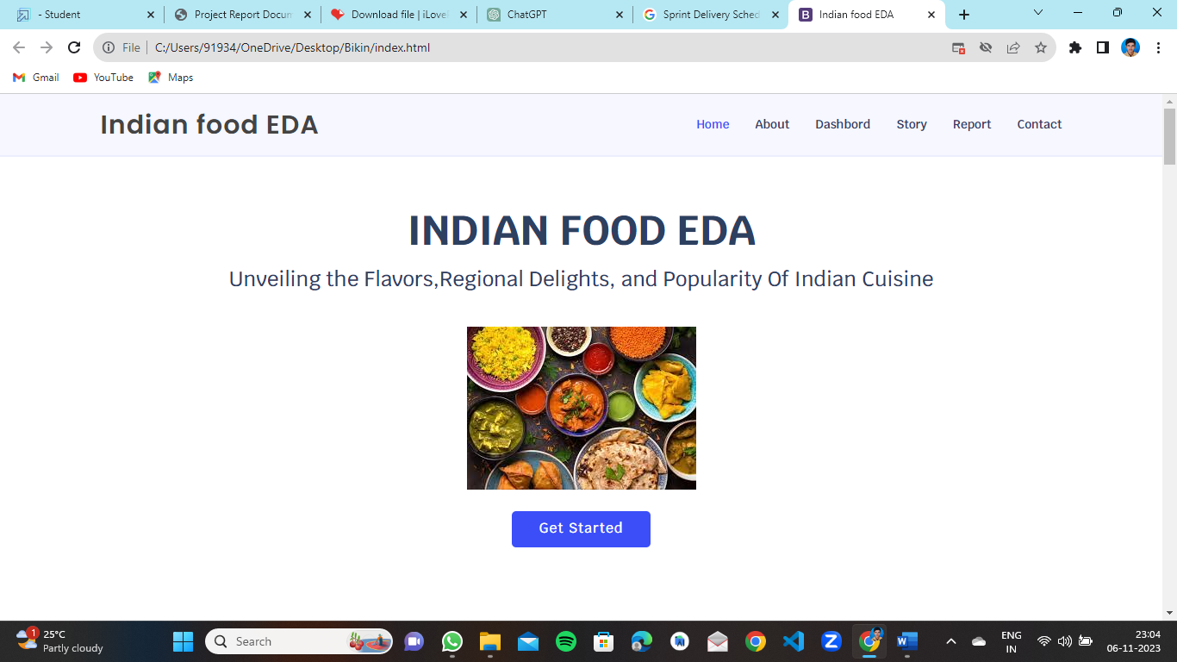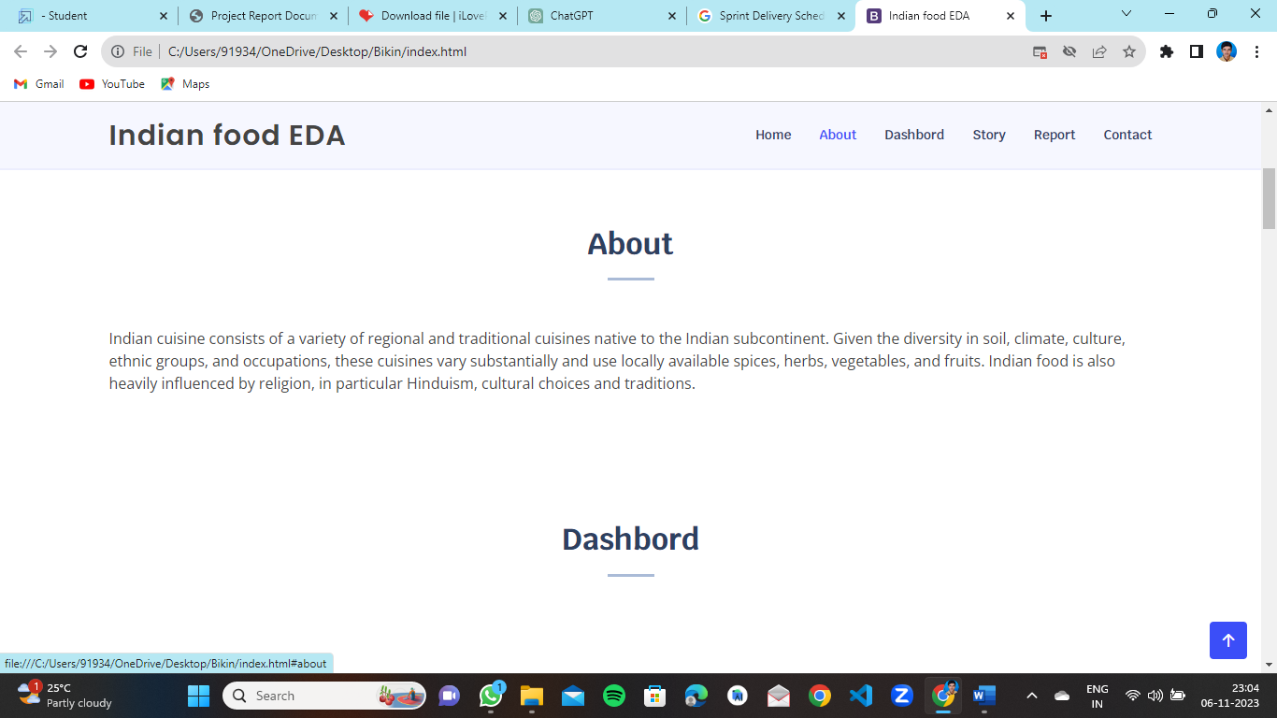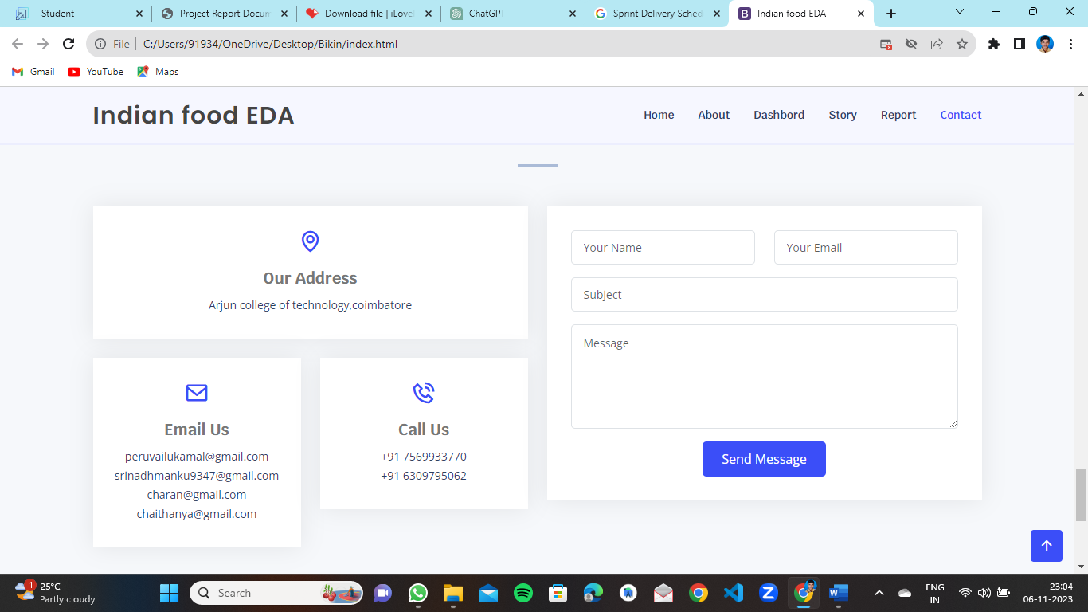

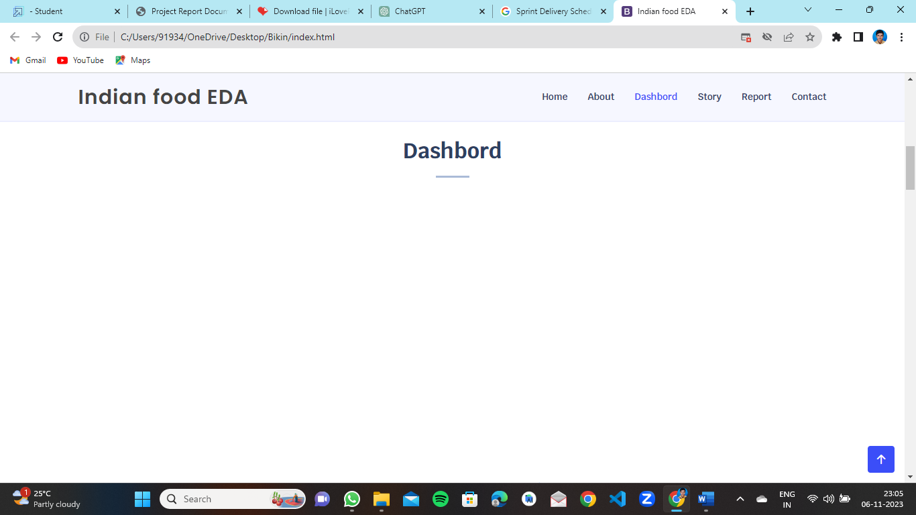

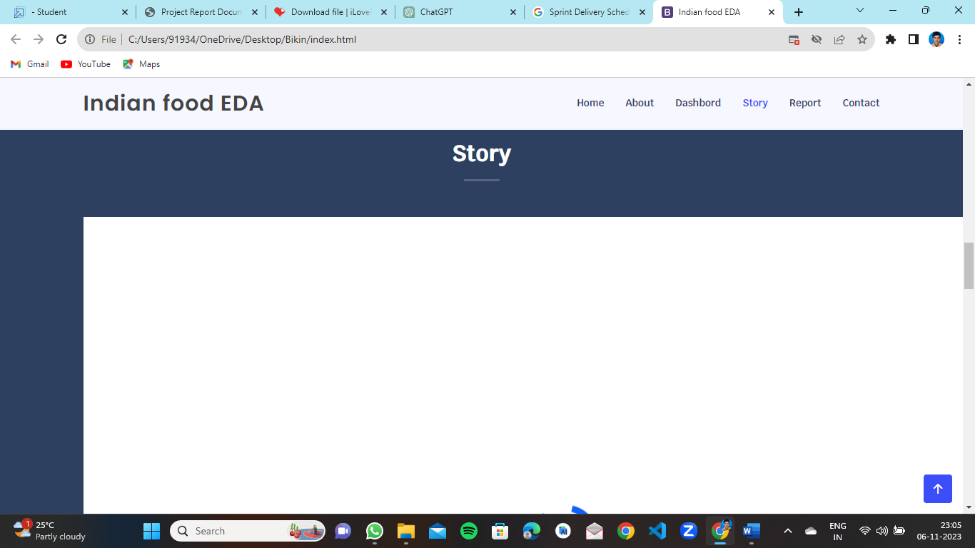

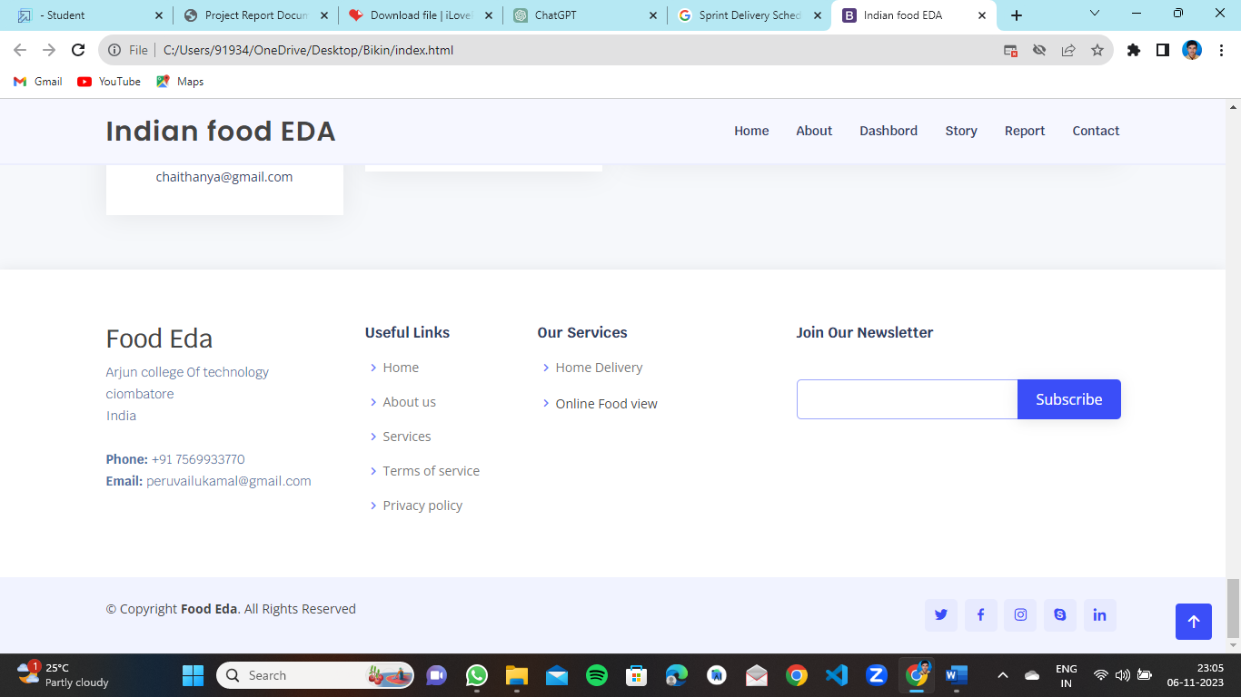

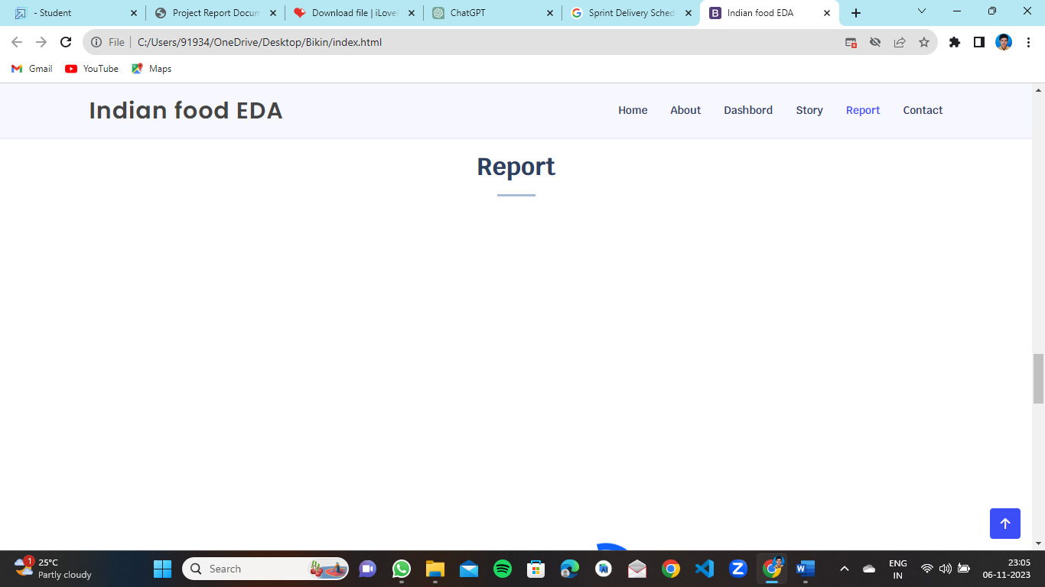



# 10.ADVANTAGES & DISADVANTAGES

# Advantages of Food EDA:

# 1. Data-Driven Decision Making: EDA allows for data-driven decision-making in the food industry. It provides insights into consumer behavior, food trends, nutritional content, and other factors that can inform product development, marketing strategies, and supply chain decisions.

# 2. Identification of Trends and Patterns: EDA can uncover hidden trends and patterns in food-related data, helping businesses and researchers identify emerging market trends, consumer preferences, and potential opportunities.

# 3. Quality Control: EDA can be used to monitor and improve food quality and safety. By analyzing data related to food quality parameters, companies can detect issues early and implement corrective measures.

# 4. Waste Reduction: Data analysis can help reduce food waste by optimizing inventory management and distribution. EDA can identify areas in the supply chain where waste occurs and suggest ways to minimize it.

# 5. Nutritional Insights: EDA is valuable for assessing the nutritional content of food products. It can aid in developing healthier food options and complying with nutritional regulations.

# 6. Cost Efficiency: EDA can lead to cost savings by identifying inefficiencies in the food production process, optimizing resource allocation, and reducing operational costs.

# 7. Market Segmentation: By analyzing consumer data, EDA can assist in market segmentation, allowing businesses to tailor their products and marketing strategies to different consumer groups.

# Disadvantages of Food EDA:

# 1. Data Complexity: Food data can be complex, with multiple variables and attributes. Handling and analyzing large and complex datasets can be challenging, requiring advanced analytical skills and tools.

# 2. Data Quality: The accuracy and reliability of food data can vary, and poor data quality can lead to misleading results. Cleaning and preprocessing data can be time-consuming.

# 3. Privacy Concerns: Consumer-related data used in food EDA, such as purchasing habits, may raise privacy concerns. Protecting sensitive data and complying with data privacy regulations is essential.

# 4. Resource Intensive: Effective EDA may require significant resources, including data collection, storage, processing, and analysis tools. Smaller businesses or research projects with limited resources may face challenges.

# 5. Bias and Interpretation: EDA results can be influenced by bias in data collection or analysis. Interpreting the results in an unbiased manner is essential for valid insights.

# 6. Limited Predictive Power: EDA is primarily focused on exploring and understanding data, rather than making predictions. It may not provide specific predictive models or forecasts, which could be a limitation for businesses looking for predictive insights.

# 7. Dynamic Nature of Food Trends: The food industry is highly dynamic, with rapidly changing consumer preferences and trends. EDA results may become quickly outdated, requiring ongoing analysis to stay relevant.

# 8. Complex Regulations: The food industry is subject to complex and evolving regulations. Adhering to these regulations while conducting EDA can be challenging, especially when dealing with large datasets.

# 11.CONCLUSION

In conclusion, food exploratory data analysis (EDA) plays a pivotal role in unlocking a world of insights within the vast and complex domain of food. Through the systematic examination of data related to nutrition, consumer behavior, supply chain, safety, marketing, and emerging trends, EDA provides a data-driven lens through which we can better understand the multifaceted aspects of food. By conducting a comprehensive literacy survey and defining a problem statement, we establish a strong foundation for meaningful analysis. EDA empowers us to make informed decisions that can positively impact public health, environmental sustainability, and the quality of the food we consume. It not only reveals hidden patterns and trends but also identifies opportunities for improvement and innovation in the food industry. Ultimately, food EDA contributes to a healthier, more sustainable, and more informed future in the realm of food and nutrition.

# 12.FUTURE SCOPE:

# The future scope of food exploratory data analysis (EDA) holds immense promise as we navigate an ever-evolving landscape of challenges and opportunities in the food domain. With the increasing availability of diverse and comprehensive food-related datasets, EDA is poised to play a pivotal role in shaping the way we produce, consume, and think about food.Firstly, the integration of emerging technologies such as artificial intelligence, machine learning, and Internet of Things (IoT) into EDA tools will enable us to process and interpret data more efficiently. This will lead to more precise insights, improved predictive models, and real-time monitoring of food-related variables, contributing to enhanced food safety and quality.Secondly, the growing emphasis on sustainability in the food industry will drive the future scope of EDA. As consumers and businesses alike become more environmentally conscious, EDA can help assess the environmental impact of food production and supply chains. It can guide the development of sustainable practices and support the circular economy in the food sector.

**13.APPENDIX:**

An appendix is a section of a document, typically found at the end, that contains supplementary or additional information that is relevant to the main content but not essential for the main body of the document. Appendices are often used to include data, charts, tables, graphs, detailed information, or supporting documents that may be useful for readers who want to delve deeper into a particular topic without cluttering the main text. The specific content of an appendix will vary depending on the document's purpose and subject matter. Appendices are usually labeled with letters (e.g., "Appendix A," "Appendix B") and referenced in the main text when needed. They provide a way to maintain a clean and organized main document while still making important supplementary information available to the reader.

**Source code:**

<!DOCTYPE html>

<html lang="en">

<head>

  <meta charset="utf-8">

  <meta content="width=device-width, initial-scale=1.0" name="viewport">

  <title>Indian food EDA</title>

  <meta content="" name="description">

  <meta content="" name="keywords">

  <!-- Favicons -->

  <link href="assets/img/favicon.png" rel="icon">

  <link href="assets/img/apple-touch-icon.png" rel="apple-touch-icon">

  <!-- Google Fonts -->

  <link href="https://fonts.googleapis.com/css?family=Open+Sans:300,300i,400,400i,600,600i,700,700i|Krub:300,300i,400,400i,500,500i,600,600i,700,700i|Poppins:300,300i,400,400i,500,500i,600,600i,700,700i" rel="stylesheet">

  <!-- Vendor CSS Files -->

  <link href="assets/vendor/aos/aos.css" rel="stylesheet">

  <link href="assets/vendor/bootstrap/css/bootstrap.min.css" rel="stylesheet">

  <link href="assets/vendor/bootstrap-icons/bootstrap-icons.css" rel="stylesheet">

  <link href="assets/vendor/boxicons/css/boxicons.min.css" rel="stylesheet">

  <link href="assets/vendor/glightbox/css/glightbox.min.css" rel="stylesheet">

  <link href="assets/vendor/swiper/swiper-bundle.min.css" rel="stylesheet">

  <!-- Template Main CSS File -->

  <link href="assets/css/style.css" rel="stylesheet">

  <!-- =======================================================

  * Template Name: Bikin

  * Updated: Sep 18 2023 with Bootstrap v5.3.2

  * Template URL: https://bootstrapmade.com/bikin-free-simple-landing-page-template/

  * Author: BootstrapMade.com

  * License: https://bootstrapmade.com/license/

  ======================================================== -->

</head>

<body>

  <!-- ======= Header ======= -->

  <header id="header" class="fixed-top">

    <div class="container d-flex align-items-center justify-content-between">

      <h1 class="logo"><a href="index.html"></a>Indian food EDA</h1>

      <!-- Uncomment below if you prefer to use an image logo -->

      <!-- <a href="index.html" class="logo"><img src="assets/img/logo.png" alt="" class="img-fluid"></a>-->

      <nav id="navbar" class="navbar">

        <ul>

          <li><a class="nav-link scrollto active" href="#hero">Home</a></li>

          <li><a class="nav-link scrollto" href="#about">About</a></li>

          <li><a class="nav-link scrollto" href="#dashbord">Dashbord</a></li>

          <li><a class="nav-link scrollto" href="#story">Story</a></li>

          <li><a class="nav-link scrollto " href="#report">Report</a></li>

          <li><a class="nav-link scrollto" href="#contact">Contact</a></li>

        <i class="bi bi-list mobile-nav-toggle"></i>

      </nav><!-- .navbar -->

    </div>

  </header><!-- End Header -->

  <!-- ======= Hero Section ======= -->

  <section id="hero" class="d-flex align-items-center">

    <div class="container d-flex flex-column align-items-center justify-content-center" data-aos="fade-up">

      <h1>INDIAN FOOD EDA</h1>

      <h2>Unveiling the Flavors,Regional Delights, and Popularity Of Indian Cuisine</h2>

      <img src="C:\Users\91934\Downloads\download.jpg" class="img-fluid hero-img" alt="" data-aos="zoom-in" data-aos-delay="400">

      <a href="#about" class="btn-get-started scrollto">Get Started</a>

    </div>

  </section><!-- End Hero -->

  <main id="main">

    <!-- ======= About Section ======= -->

    <!-- End About Section -->

    <!-- ======= Clients Section ======= -->

    <!-- End Clients Section -->

    <section id="about" class="features" data-aos="fade-up">

      <div class="container">

        <div class="section-title">

          <h2>About</h2>

        </div>

        <p>Indian cuisine consists of a variety of regional and traditional cuisines native to the Indian subcontinent. Given the diversity in soil, climate, culture, ethnic groups, and occupations, these cuisines vary substantially and use locally available spices, herbs, vegetables, and fruits. Indian food is also heavily influenced by religion, in particular Hinduism, cultural choices and traditions.</p>

        </div>

    </section>

    <!-- ======= Features Section ======= -->

    <section id="dashbord" class="features" data-aos="fade-up">

      <div class="container">

        <div class="section-title">

          <h2>Dashbord</h2>

        </div>

        <iframe src="https://us3.ca.analytics.ibm.com/bi/?perspective=dashboard&amp;pathRef=.my_folders%2FIndia%2Beda%2Bdashboard&amp;closeWindowOnLastView=true&amp;ui_appbar=false&amp;ui_navbar=false&amp;shareMode=embedded&amp;action=view&amp;mode=dashboard&amp;subView=model0000018b8623a701_00000000" width="1350" height="900" frameborder="0" gesture="media" allow="encrypted-media" allowfullscreen=""></iframe>

      </div>

    </section><!-- End Features Section -->

    <!-- ======= Steps Section ======= -->

    <!-- End Steps Section -->

    <!-- ======= Services Section ======= -->

    <section id="story" class="services">

      <div class="container" data-aos="fade-up">

        <div class="section-title">

          <h2>Story</h2>

          </div>

          <iframe src="https://us3.ca.analytics.ibm.com/bi/?perspective=story&amp;pathRef=.my_folders%2FStory%253A%2BIndia%2Beda%2Bstory&amp;closeWindowOnLastView=true&amp;ui_appbar=false&amp;ui_navbar=false&amp;shareMode=embedded&amp;action=view&amp;sceneId=-1&amp;sceneTime=0" width="1350" height="900" frameborder="0" gesture="media" allow="encrypted-media" allowfullscreen=""></iframe>

      </div>

    </section><!-- End Services Section -->

    <!-- ======= Portfolio Section ======= -->

    <section id="report" class="portfolio">

      <div class="container" data-aos="fade-up">

        <div class="section-title">

          <h2>Report</h2>

          </div>

          <iframe src="https://us3.ca.analytics.ibm.com/bi/?perspective=story&amp;pathRef=.my_folders%2FStory%253A%2BIndia%2Beda%2Bstory&amp;closeWindowOnLastView=true&amp;ui_appbar=false&amp;ui_navbar=false&amp;shareMode=embedded&amp;action=view&amp;sceneId=-1&amp;sceneTime=0" width="1350" height="900" frameborder="0" gesture="media" allow="encrypted-media" allowfullscreen=""></iframe>

      </div>

    </section><!-- End Portfolio Section -->

    <!-- ======= Testimonials Section ======= -->

    <!-- End Testimonials Section -->

    <!-- ======= Team Section ======= -->

    <!-- End Team Section -->

    <!-- ======= Pricing Section ======= -->

    <!-- ======= Contact Section ======= -->

    <section id="contact" class="contact section-bg">

      <div class="container" data-aos="fade-up">

        <div class="section-title">

          <h2>Contact</h2>

           </div>

        <div class="row">

          <div class="col-lg-6">

            <div class="row">

              <div class="col-md-12">

                <div class="info-box">

                  <i class="bx bx-map"></i>

                  <h3>Our Address</h3>

                  <p>Arjun college of technology,coimbatore</p>

                </div>

              </div>

              <div class="col-md-6">

                <div class="info-box mt-4">

                  <i class="bx bx-envelope"></i>

                  <h3>Email Us</h3>

                  <p>peruvailukamal@gmail.com<br>srinadhmanku9347@gmail.com<br>charan@gmail.com<br>chaithanya@gmail.com</p>

                </div>

              </div>

              <div class="col-md-6">

                <div class="info-box mt-4">

                  <i class="bx bx-phone-call"></i>

                  <h3>Call Us</h3>

                  <p>+91 7569933770<br>+91 6309795062</p>

                </div>

              </div>

            </div>

          </div>

          <div class="col-lg-6 mt-4 mt-md-0">

            <form action="forms/contact.php" method="post" role="form" class="php-email-form">

              <div class="row">

                <div class="col-md-6 form-group">

                  <input type="text" name="name" class="form-control" id="name" placeholder="Your Name" required>

                </div>

                <div class="col-md-6 form-group mt-3 mt-md-0">

                  <input type="email" class="form-control" name="email" id="email" placeholder="Your Email" required>

                </div>

              </div>

              <div class="form-group mt-3">

                <input type="text" class="form-control" name="subject" id="subject" placeholder="Subject" required>

              </div>

              <div class="form-group mt-3">

                <textarea class="form-control" name="message" rows="5" placeholder="Message" required></textarea>

              </div>

              <div class="my-3">

                <div class="loading">Loading</div>

                <div class="error-message"></div>

                <div class="sent-message">Your message has been sent. Thank you!</div>

              </div>

              <div class="text-center"><button type="submit">Send Message</button></div>

            </form>

          </div>

        </div>

      </div>

    </section><!-- End Contact Section -->

  </main><!-- End #main -->

  <!-- ======= Footer ======= -->

  <footer id="footer">

    <div class="footer-top">

      <div class="container">

        <div class="row">

          <div class="col-lg-3 col-md-6 footer-contact">

            <h3>Food Eda</h3>

            <p>

              Arjun college Of technology <br>

              ciombatore<br>

              India <br><br>

              <strong>Phone:</strong> +91 7569933770<br>

              <strong>Email:</strong> peruvailukamal@gmail.com<br>

            </p>

          </div>

          <div class="col-lg-2 col-md-6 footer-links">

            <h4>Useful Links</h4>

            <ul>

              <li><i class="bx bx-chevron-right"></i> <a href="#">Home</a></li>

              <li><i class="bx bx-chevron-right"></i> <a href="#">About us</a></li>

              <li><i class="bx bx-chevron-right"></i> <a href="#">Services</a></li>

              <li><i class="bx bx-chevron-right"></i> <a href="#">Terms of service</a></li>

              <li><i class="bx bx-chevron-right"></i> <a href="#">Privacy policy</a></li>

            </ul>

          </div>

          <div class="col-lg-3 col-md-6 footer-links">

            <h4>Our Services</h4>

            <ul>

              <li><i class="bx bx-chevron-right"></i> <a href="#">Home Delivery</a></li>

              <li><i class="bx bx-chevron-right"></i> <a href="#"></a>Online Food view</li>

            </ul>

          </div>

          <div class="col-lg-4 col-md-6 footer-newsletter">

            <h4>Join Our Newsletter</h4>

            <form action="" method="post">

              <input type="email" name="email"><input type="submit" value="Subscribe">

            </form>

          </div>

        </div>

      </div>

    </div>

    <div class="container d-md-flex py-4">

      <div class="me-md-auto text-center text-md-start">

        <div class="copyright">

          &copy; Copyright <strong><span>Food Eda</span></strong>. All Rights Reserved

        </div>

        <div class="credits">

          <!-- All the links in the footer should remain intact. -->

          <!-- You can delete the links only if you purchased the pro version. -->

          <!-- Licensing information: https://bootstrapmade.com/license/ -->

          <!-- Purchase the pro version with working PHP/AJAX contact form: https://bootstrapmade.com/bikin-free-simple-landing-page-template/ -->

        </div>

      </div>

      <div class="social-links text-center text-md-right pt-3 pt-md-0">

        <a href="#" class="twitter"><i class="bx bxl-twitter"></i></a>

        <a href="#" class="facebook"><i class="bx bxl-facebook"></i></a>

        <a href="#" class="instagram"><i class="bx bxl-instagram"></i></a>

        <a href="#" class="google-plus"><i class="bx bxl-skype"></i></a>

        <a href="#" class="linkedin"><i class="bx bxl-linkedin"></i></a>

      </div>

    </div>

  </footer><!-- End Footer -->

  <div id="preloader"></div>

  <a href="#" class="back-to-top d-flex align-items-center justify-content-center"><i class="bi bi-arrow-up-short"></i></a>

  <!-- Vendor JS Files -->

  <script src="assets/vendor/aos/aos.js"></script>

  <script src="assets/vendor/bootstrap/js/bootstrap.bundle.min.js"></script>

  <script src="assets/vendor/glightbox/js/glightbox.min.js"></script>

  <script src="assets/vendor/isotope-layout/isotope.pkgd.min.js"></script>

  <script src="assets/vendor/swiper/swiper-bundle.min.js"></script>

  <script src="assets/vendor/php-email-form/validate.js"></script>

  <!-- Template Main JS File -->

  <script src="assets/js/main.js"></script>

</body>

</html>

**PROJECT VIDEO DEMO LINK :**

<https://drive.google.com/file/d/1bWkpH8hZ-8fvolsFAcz8S790mwPrhWVy/view?usp=sharing>

**GITHUB LINK:**

<https://github.com/peruvailukamal/Indian-Food-EDA>